Possible Economic Effects of European Debt and Low U.S. Interest Rates

John Lifflander, ASA
Covenant Consultants, Inc.
Ridgefield, Washington, 98642
(360) 687-1602
John@ccitax.com
www.ccitax.com

Manipulating the Money Supply and Controlling Interest Rates

The Fed controls the money supply by setting interest rates, but how can the Fed make money out of thin air? Is the money supply limited, or can the United States print and spend as much money as it wants to? The answer is that the money supply is not limited, because it is not tied to gold or any other commodity, as it was in the past, so it can be expanded by simply printing (or electronically expanding) more of it. Until 1972, the United States was on the gold standard, which meant that the dollar was redeemable for 1/35th of an ounce of gold, under a system that was called Bretton Woods. President Nixon took the United States off that standard in 1972, and the dollar then became what is known as fiat currency. The following is a definition of fiat currency from businessdictionary.com. Fiat money: money (as paper currency) not convertible into coin or specie of equivalent value. (http://www.webstersonline-dictionary.org/definition/ fiat+money)

Low interest rates effectively raise the cost of real estate, so when interest rates rise we can expect values to drop. For a proper perspective on this, consider two extremes. At one extreme, imagine how much real estate would cost if no loans were available to purchase it. If every piece of real estate could only be purchased in cash, how many people could afford to buy it? At the other extreme, imagine loans that have an interest rate of zero percent, that require no down payment, and that are available to everyone regardless of their credit rating or income.

It’s the Monthly Payment, Not the Price

What would prices be under each scenario? Because the U.S. economy is credit-driven, most buyers of real estate look at the monthly payment rather than the total cost. Thus, prices would plummet in the first scenario and skyrocket in the second. For instance, a $500,000 mortgage amortized for 30 years has a monthly payment of $2,358 at 3.9%, and $4,023 at 9%, which was a normal rate for many years in the past. Therefore, price fluctuations are based on the interest rate paid (also known as the cost of money) and the availability of credit, both of which are to a great extent controlled by the government and, more specifically, the Federal Reserve Bank. The Fed indirectly causes mortgage lending rates to go up or down by setting the interest rate that banks are charged for borrowing from it, and that rate is called the discount rate. The power to set rates has always rested with the Fed, but it has rarely been pushed to one extreme as it has today.

Historically, the last time rates were pushed to an extreme was under President Jimmy Carter in the late 1970s and early 1980s. At that time the United States was experiencing increasing inflation, and to stem it, the Fed raised rates until a mortgage could cost 18 percent. This rate increase put the brakes on inflation, but it also stopped business in its tracks and lending slowed to a dribble, causing financial failure for many business entities and throwing the country into a recession. The spike in that time period is shown in the following figure. The chart below shows the history of interest rates.

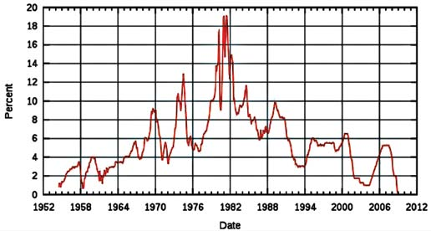
Unintended Ramifications of Low Interest Rates

Keeping interest rates low causes difficulty for people who are trying to save, for those who live on fixed incomes with interest from savings, and for those who are trying to save for retirement. Many retired persons relying on income from savings have seen their incomes drop drastically in the past decade. Consider the difference in income for the person who has $1,000,000 in the bank. The current CD (certificate of deposit) or money market rate is about .7 percent, which returns an annual yield of $7,000. Just a few years or so ago, the rate was about 5 percent, which would yield $50,000 a year. Many years ago, a 9 percent rate would have yielded $90,000. At the 9 percent rate, and 5 percent rate, the person might have enough income to live on, but not at the current, lower rate. So those with money in savings are essentially penalized when rates are held down to benefit those who borrow.
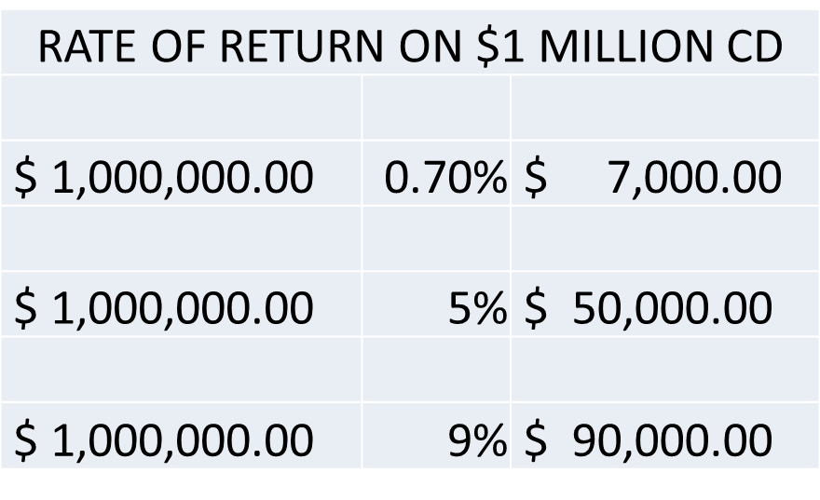

Another result of these low rates is that some people have been lured into riskier investments, such as stocks, and have suffered losses. Had the rates stayed higher, many of them would have left their money in Federal Deposit Insurance Corporation (FDIC) insured accounts. Some of these people may have also invested in real estate seeking higher returns, which helped expand the recently burst bubble, and then suffered a loss when the real estate market collapsed.
Another by-product of the low rates is over-borrowing—particularly in the business sector. When money is cheap, businesses tend to spend more and expand when they might not have otherwise. The consequence of this is obvious—many companies that geared up for the overheated economy caused by the bubble are now facing higher fixed operating costs as the demand for goods has diminished.
Moreover, most business loans are not long-term loans, and many lenders are no longer interested in renewing current loans, which can put even a viable business in a predicament. Many commercial real estate borrowers face the same problem. Commercial loans are normally made with a renewal period every 3 to 5 years, but they are amortized over a longer period, generally 20 to 25 years. Lenders generally tell commercial borrowers that renewal will not be a problem when the loan is made, but now things are changing.
Values are dropping, and many lenders are not renewing commercial loans, including those that have been paid on time. In one particular instance, a commercial loan for a shopping center for $6 million was not renewed, even though the borrower had good credit and the center was performing well. The answer from the bank was that it did not want to continue lending on commercial properties because of the dismal outlook.
With values dropping, often assessors are not keeping up, and requests for reductions are often questioned, based on the previous sale price of the property or business.

The exact numbers are not known, but according to the Real Estate Roundtable, (http://www.rer.org/2012_Policy_Agenda.aspx) there is about 362 billion of commercial real estate (CRE) and commercial mortgage backed securities (CMBS) that needs to be refinanced in 2012, but only 30-55 billion available to lend. They also estimate that 60% of the 1.4 trillion of CRE in the United States is underwater and is maturing from 2012 to 2015. (Real Estate Roundtable, Policy Agenda, Executive Summary, 2012). The following charts show the drop in value since 2008, and the breakout of debt holders for CRE.

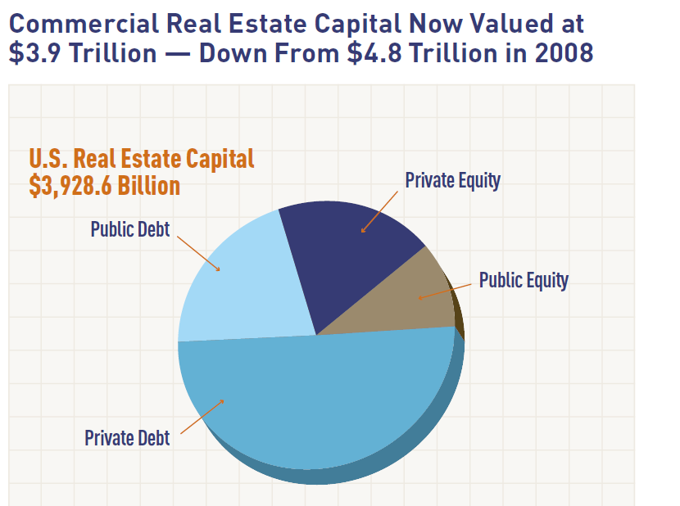

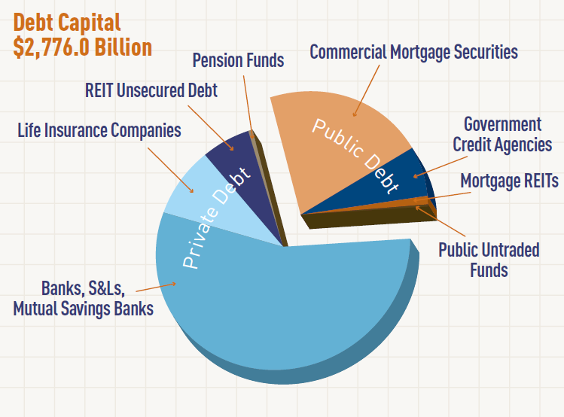

Educating Economists

So what happened to get rates this low – is there a theory behind it? Yes, there definitely is, and a quote by Abraham Lincoln is appropriate here:

"The philosophy of the classroom of one generation will be the philosophy of the government of the next generation."-Abraham Lincoln

"The philosophy of the classroom of one generation will be the philosophy of the government of the next generation.“

-Abraham Lincoln (SLIDE)

When I took economics in college, which was about forty years ago, I was taught there was a basic, first rule in economics – there is no free lunch. But that concept was countered then by some economists who shrouded economic theory in mystery and acted as if economic prosperity could be created from nothing. And it was an economist from about a generation before that time started the new thinking.

That economist was John Maynard Keynes, and in 1936 he advised Roosevelt that the economy could be controlled by using government intervention, including what today is called stimulus funds (Keynes 2007). His consultations with Roosevelt resulted in a huge increase in public spending, some of which started the WPA (Works Projects Administration), which became the largest employer in United States at that time, and the CCC (Civilian Conservation Corps), which also produced jobs.

Keynes also believed that excessive savings was bad, because it slowed the economy (the less people spend, the less economic activity), and he thought that debt was good and should be used by governments in their manipulation of the economy. This is a gross simplification of his theories, but the scope of this article does not permit a more detailed explanation. However, the following quotes regarding Keynes are instructive.

In 1971, Republican U.S. President Richard Nixon proclaimed, “we are all Keynesians now” (Lewis 1976). In 1999, Time magazine named Keynes one of the 100 Most Important People of the 20th Century (http://en.wikipedia.org/wiki/ John_Maynard_Keynes) and reported that, “His radical idea that governments should spend money they don’t have may have saved capitalism” (Reich 1999). An article in the U.K. publication, The Financial Times, stated that Keynesian economics has provided the theoretical underpinning for the plans of President Barack Obama, Prime Minister Gordon Brown, and other global leaders to rescue the world economy (Giles, Atkins, and Guha 2008).

From Nixon to Obama, both Republicans and Democrats have embraced Keynes, and many have believed that his theories would cause continued prosperity. The current Fed Chairman, Ben Bernanke, believes that the United States could have avoided the Great Depression if the government had spent more money and lowered interest rates more. As noted in the following comment, he has specific views on the subject. “The financial crisis has made Federal Reserve Chairman Ben Bernanke’s book Essays on the Great Depression a hot seller. . . . Bernanke, a former Princeton University economist, is considered the pre-eminent living scholar of the Great Depression. He is practicing today what he preached in his book: Flood the system with money to avoid a depression.” (Cauchon 2008)

Before Bernanke wrote his book, Milton Friedman, economist and advisor to Presi-dent Reagan, stated that he believed that lowering interest rates (known as mone-tarism) would have kept the United States out of the Great Depression, in opposition to Keynes, who claimed that large-scale deficit spending was the only way out. Bernanke agrees with Friedman, and said so in a speech celebrating Friedman’s 90th birthday on November 8, 2002. Addressing Friedman’s ideas that the government was to blame for the Great Depression by not lowering interest rates and freeing up funds to borrow, Bernanke said, “You’re right, we did it. We’re very sorry. But thanks to you, we won’t do it again” (Bernanke 2002).

“You’re right, we did it. We’re very sorry. But thanks to you, we won’t do it again” (Bernanke 2002). (Slide)

Tale of Two Theories

In the Great Depression, jobs were created by the government, but the money supply was not expanded the way it has been in the current crisis. Essentially, in the current financial crisis, Keynes’s ideas have been implemented (stimulus funds) in conjunction with Friedman’s ideas (low interest rates). In addition, huge bailouts have been made for various companies and industries. Chairman Bernanke and many others believe that if these measures had not been implemented, the country would be in dire financial straits and in a depression as severe as the one that occurred in 1929.

On the other end of the spectrum, the more classical economists might say that none of the government’s actions have been proper, nor will they work for very long. The “no free lunch” crowd believes that making credit easy, throwing money at the problem, bailing out failing institutions, and lowering interest rates only puts off a day of reckoning that must occur, as the market finds equilibrium. Many of these economists believe that massive inflation will follow the expansion of the money supply and that bubbles in markets such as real estate are only prolonged when rates are held down and incentives are offered to purchase homes.

In any event, soon after the debt crisis hit in 2008, Bernanke nearly tripled the size of the Fed’s balance sheet from about 6% of GDP to almost 17% of GDP. And following suit, in what appears to almost be a global race to print money, the European Central Bank (ECB) which has been leading for the past year or so,
suddenly expanding their balance sheet from about 20% of GDP to close to 30% of GDP.

The Dollar as the Reserve Currency of the World

All modern governments use fiat money, but the dollar has been the reserve currency of the world for many decades and has this status because international finance is often transacted in dollars, governments around the world invest in dollars, and oil is purchased in dollars, among other things. The Chinese government is the biggest investor in dollars, Japan is second, and the United Kingdom and oil producing countries are a distant third and fourth. After them, many other countries have smaller holdings. Foreign governments buy dollars because the United States has been the most stable economy in the world, and as the premier superpower, it has the most powerful military. Consequently, the United States has been able to use its fiat money on an international scale, which has allowed it to borrow more money than other countries, through the issuance of Treasury bills, notes, and bonds (treasuries).

As Bevan (2005) notes, Unlike other countries that are constricted by issues such as balance of payments and debt, the United States developed a system whereby it issues a fiat currency that the rest of the world must use.

Selling Dollars around the World

However, the unique position the United States holds in the world is beginning to change, and one reason is the marked increase in spending that it has recently indulged in. Budgets in the past have often increased 20 or 30 percent, but the current administration is spending 3.5 times the previous budget and it is still increasing. This spending has been used to help the economy in a time of crisis, but the result has been that the countries that buy dollars are having second thoughts about continuing their investments. They realize that as more dollars are printed, inflation must ensue, which will reduce the value of their holdings. But if they pull out of dollars quickly, the United States will suffer economically, which will decrease its buying power, causing economic woes for these countries, because they depend on the United States as a primary market for their goods. Consequently, they are not pleased with the situation, as evidenced by the following quote from a Chinese official:

“We hate you guys, but there is nothing much we can do.” Luo Ping, a director general at China’s Banking Regulatory Commission, saying Beijing will continue to buy U.S. Treasury bonds despite concerns about the dollar. China has nearly $2 trillion in foreign-currency reserves— February. (Verbatim, Time, December 28, 2009).

The following is a chart showing the largest bond holders of the U.S. currency:

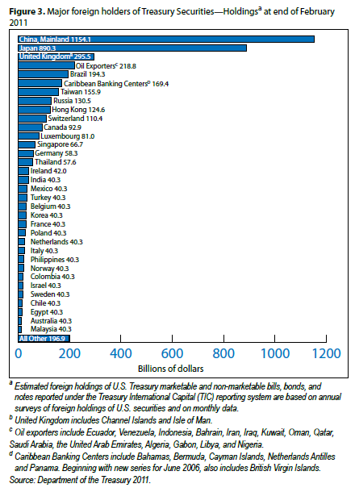

For a while, some countries were slowly pulling out of dollar investments in 2009. On a weekly basis, the United States sells treasuries for government funding. They are sold in various forms: 4-week, 3-month, and 6-month bills and 3-, 5-, 7-, 10-, and 30-year notes. Besides foreign central banks, bidders are individual investors, pension funds, mutual funds, and other buyers.

The more bidders and the more they are willing to pay, the lower the yields the Treasury has to pay on these securities, lowering the U.S. government’s financing costs. Treasuries were still selling, but were slowing down, especially for the longer term notes. There had been no “failed” auctions, which would occur when the government cannot get $1 in bids for every $1 in securities sold. But that had happened in the United Kingdom. (Larson 2009)

The U.S. would have been forced to raise rates to keep the debt binge going, but we got a major reprieve. Just when the Euro looked like it would become the new reserve currency of the world, the bailouts in Europe began, make the Euro even more questionable than the dollar. The agreements for the European Union was that countries would not exceed certain debt limits, and those that did would be expelled from the E.U. But when Greece and other countries exceeded the debt limits without penalties, and when Greece began to default, the rules were broken and Greece was bailed out.

Predicting Based on What Is Known

It goes without saying that no one knows the future, but people make educated guesses based on past and current knowledge in many aspects of their lives. For instance, prior to traveling, if there is a report of inclement weather, people prepare even though it is only a forecast. At present, interest rates are the lowest they have been in at least six decades, so it may be reasonable to expect that they will go up in the future.

As discussed, the U.S. government must sell treasuries to continue to get funding, and eventually it would appear that rates must increase. The government itself is aware that interest rates must rise to continue to fund the debt; see the article “Nowhere to go but up: Managing interest rate risk in a low-rate environment” in the FDIC publication Supervisory Insights (Clair, Touhey, and Turbeville 2009). The title itself reveals what we already know from historical knowledge—rates can only go up because they have nowhere else to go. The discount rate is about the lowest it can be, so there is virtually no more margin to reduce it and make money any cheaper. The FDIC article deals more with short-term rates than long-term rates, but if yields increase in the short term, investors will likely stop investing in the longer term notes.

Nevertheless, rates will not go up without a struggle, because the Federal Reserve is trying to keep rates down for as long as it can. Chairman Bernanke is aware that in 1937–1938 the Fed prematurely hiked rates, which many think prolonged the Great Depression by causing a “double dip” in the economy. The Fed is concerned that history will repeat itself 70 years later, so it is likely that it will only increase rates when it is forced to, due to treasuries selling at lower rates. However, it is also possible that it will seek another way to keep them down to continue the status quo. Nevertheless, it would appear that a rate increase must come eventually.

Possible Results of an Interest Rate Increase

If real estate buyers purchase based on the monthly payment and not on the total price, then an increase in interest rates will cause a decrease in prices, if all other variables remain constant. Refinancing activity will also decrease if rates go up even 1 percent, and sales will slow, causing a further decline in economic activity and real estate values.

When this situation is analyzed to include other variables, (because in reality they do not remain constant) the prognosis will vary depending on the economic circumstances of the locality. Supply and demand is still foundational—in some areas there is an excess of properties; in others demand is stronger. Moreover, since building activity is low, demand should increase over time as existing properties are absorbed. One caveat to this conclusion is that if unemployment continues on its current upward trend, foreclosures may put more properties on the market, slowing absorption.

More Inflation on the Horizon

Since real estate is still in a crisis mode in many areas and foreclosures are continuing, it might appear unusual to expect a substantial increase in inflation. However, as the United States continues to increase the spending, borrowing, and printing of fiat money, inflation appears to be an inevitable, although perhaps belated, result. It is already appearing in the increase in commodity prices, which many have invested in because of their lack of confidence that the dollar will hold its value. But don’t look to the government inflation figures as a guide. Economists are fond of saying they are only good for people who don’t drive or eat, because energy and food are not counted, or increases in the cost of cars. However, housing prices are included, and when they are averaged into the mix, they balance the increase in other commodities, causing a distorted view of what is really happening.

The Influence of the United States

As the U.S. lowered interest rates and printed more and more money, the rest of the world took its cue from us, and also lowered them, but they did not have the ability to float their fiat money internationally, and they are paying the price now. And yet we are telling them how they must adopt austerity measures while we continue to spend more and more. It was sort of like a like teenagers getting into the wrong crowd. The have followed us into the addiction to cheap money, and they’ve been hooked. They also promised luxurious benefits for citizens which they can no longer afford, and we see the rioting that is causing.

Are We in a Cycle?

We definitely have economic cycles and things get better and worse from time to time, but in regard to increasing debt, there does not appear to be a cycle, because it rarely goes down, and when it does it seems to always go back up again. World War II was an exception, because we borrowed a lot (mainly through U.S. Bonds) to finance the war, and it was paid off afterwards. But to get an understanding of our debt situation, see the following chart:

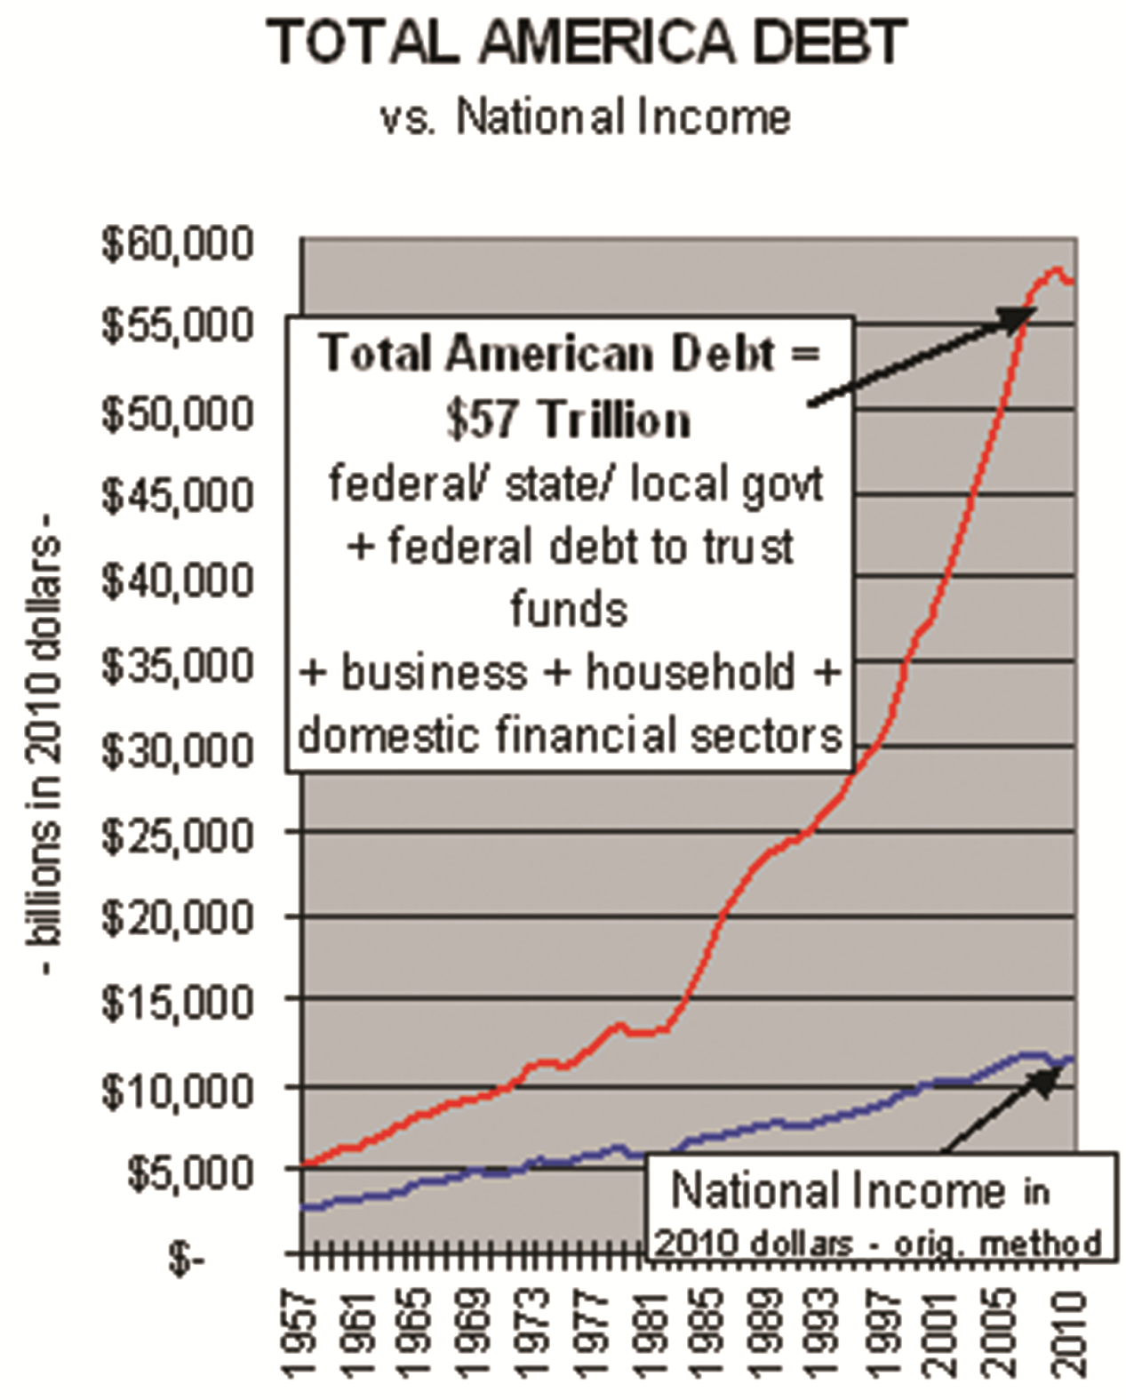

The good news is we are still a very wealthy country. There is a lot of inherent wealth in our natural resources, and innovative minds, educated people, and infrastructure. This can be overcome, but we can’t spend our way out. Ben is wrong. We need to have the austerity programs we keep telling the Europeans to have to get out of it. We can do it, but the problem has to be confronted, and people need to understand that we cannot continue to spend more and still stay productive and economically sound.

The Possible U.S. Economic Effects of the European Debt Crisis

Spain is next up for a bailout, but the difference between it and Italy is that it is five times larger. This makes it too big to fail, and perhaps too big to bail out. All of the PIIGS countries — Portugal, Ireland, Italy, Greece and Spain — are still hanging by a thread, still caught in the same vicious cycle of bulging deficits, forced cutbacks and shrinking economies. The stronger EU countries, like France and Germany have problems, which are also exacerbated by the fact that they have to find funds to bail the weaker countries out. But without that problem, they are in a crisis mode because their banks are sinking under toxic debts, and their budgets are constrained by the economic downturn they are experiencing. Moreover, the people have extremely generous social benefits and if they are taken away, more riots may ensue. The citizens of the richer countries are unhappy with the concept of a European Union, and don’t want their tax dollars used for bailouts, so political turmoil is brewing at that level, also.

There has been an unprecedented outpouring of money from the European Central Bank — more than one trillion euros given directly to private banks, who, in turn, have used most of that money to buy distressed sovereign bonds. However, this is just the beginning since there are more countries teetering on bankruptcy and default.

Five Ways E.U. Debt Can Affect the U.S.

1. We are lending Europe money through the International Monetary Fund (IMF) and through what are called currency liquidity swaps, in which the European Central Bank and four other central banks essentially borrow money from the U.S. in a somewhat complicated arrangement, perhaps made complex to quell dissent about bailing out Europe.

2. We exported about $268 billion in goods to Europe in 2011. That’s about 22% of our total exporting, which could be affected in European meltdown.

3. U.S. Banks are tied into Europes financial situation. “Our big banks are tethered at the hip to their banks, Says Mark Zandi, chief economist at Moody’s Analytics. “They are all at risk. They’re all exposed.”

U.S. banks have about 700 billion in loans in Great Britain, 300 billion in France and Germany, and 50 billion in Italy and Spain.

Specific U.S. banks are holding the following European debt: Bank of America has about 16.7 billion, Chase has about 14 billion, Citigroup 13.5 billion, Morgan Stanley, Wells Fargo, Goldman Sachs each have 3 to 5 billion.

4. There are also U.S. investments in Europe that are affected. GM owns Opel in Germany, Fiat owns Chrysler, and U.S. companies have hedge funds, credit default swaps and other complicated financial arrangements with European companies.
5. A decline in European consumption of U.S. goods and services will reduce corporate profits. The U.S. multinationals are especially vulnerable because much of their profits come from international sales. This fact will negatively impact profits at a time when inflation, higher fuel costs and the inability for companies to pass on price increases are also hampering prices.
The problem is that our economy is in a delicate situation now making us extremely susceptible, so any disruption in the Europe can have a magnified affect, compared with the situation if we had a healthy economy and were not struggling.

For further reading, please see other articles by John Lifflander posted at www.ccitax.com

